**Python Assessment 1**

Q1.

You have seen how powerful dictionary data structure is. In this assignment, given a number n, you have to write a program that generates a dictionaryd which contains (i,i*i), where i is from 1 to n (both included).Then you have to just print this dictionary d.Example:

Input: 4 will give output as{1: 1, 2: 4, 3: 9, 4: 16}

Input Format: Take the number n in a single line.

Output Format: Print the dictionary d in a single line.

Example:Input:8

Output:{1: 1, 2: 4, 3: 9, 4: 16, 5: 25, 6: 36, 7: 49, 8: 64}

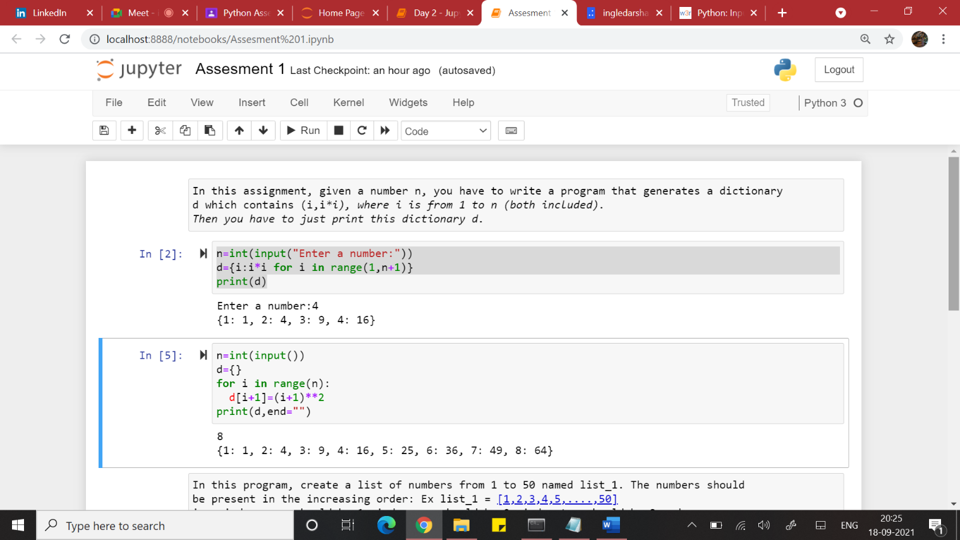

Q2.

You have also seen how list slicing is performed in python.In this program, create a list of numbers from 1 to 50 named list_1. The numbers shouldbe present in the increasing order: Ex list_1 = [1,2,3,4,5,....,50]i.e. index zero should be 1, index one should be 2, index two should be 3 and so on.Given an input of two numbers, let's say a and b, you have to print the numbers returnedby the following commandlist_1[a:b]

Input:The first line of input contains two numbers a and b separated by a space.

NOTE: You can take two inputs in a single line using the following command:a, b = input().split()

Make sure you convert the strings in a and b into integers using the int() command

Output:Print the numbers in new line

